**SOURCE CODE**

1. import pygame
2. import sys
4. def midpointEllipse(rx,ry,xc,yc):
5. x = 0
6. y = ry
7. p1 = ry * ry - rx * rx * ry + 0.25 * rx * rx
8. dx = 2 * ry * ry * x
9. dy = 2 * rx * rx * y
10. while(dx < dy):
11. **if**(p1<0):
12. x = x+1
13. y= y
14. p1 = p1+ dx + ry * ry
15. dx = 2 * ry * ry * x
16. dy = 2 * rx * rx * y
18. **else**:
19. x = x+1
20. y =y-1
21. p1 = p1 + dx - dy + ry * ry
22. dy = 2 * rx * rx * y
23. dx = 2 * ry * ry * x

26. screen.set_at((round(xc + x), round(yc + y)), WHITE)
27. screen.set_at((round(xc - x), round(yc + y)), WHITE)
28. screen.set_at((round(xc + x), round(yc - y)), WHITE)
29. screen.set_at((round(xc - x), round(yc - y)), WHITE)
31. p2 = ry * ry* (x+ 0.5) * (x+0.5) + rx*rx*(y-1)*(y-1)-rx*rx*ry*ry
33. while(y!=0):
34. **if**(p2>0):
35. x = x
36. y = y-1
37. p2 = p2 + rx * rx - dy
38. dy = 2 * rx * rx * y
39. dx = 2 * ry * ry * x
41. **else**:
42. x = x+1
43. y = y-1
44. p2 = p2 + dx - dy + rx * rx
45. dy = 2 * rx * rx * y
46. dx = 2 * ry * ry * x
48. screen.set_at((round(xc + x), round(yc + y)), WHITE)
49. screen.set_at((round(xc - x), round(yc + y)), WHITE)
50. screen.set_at((round(xc + x), round(yc - y)), WHITE)
51. screen.set_at((round(xc - x), round(yc - y)), WHITE)

54. pygame.init()
55. WIDTH = 800
56. HEIGHT = 600
58. screen = pygame.display.set_mode((WIDTH, HEIGHT))
60. pygame.display.set_caption("Midpoint Ellipse Algorithm")
62. WHITE = (255, 255, 255)
63. BLACK = (0, 0, 0)
65. def main():
66. while True:
67. for event **in** pygame.event.**get**():
68. **if** event.type==pygame.QUIT:
69. pygame.quit()
70. sys.exit()
71. screen.fill(BLACK)
72. midpointEllipse(160, 130, 400, 300)
74. pygame.display.flip()
75. pygame.time.delay(100)
77. **if** __name__ == "__main__":
78. main()

**OUTPUT**

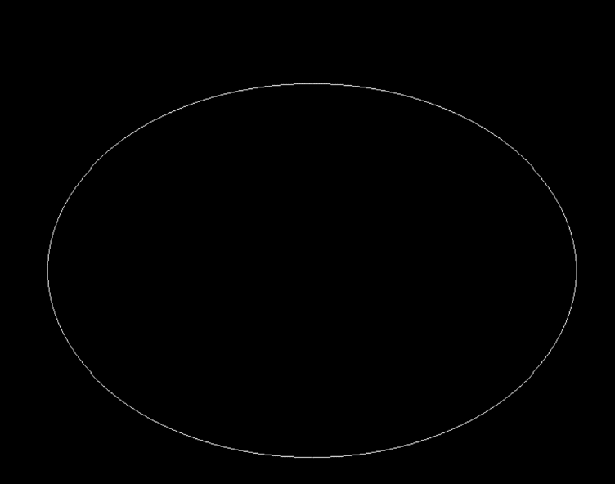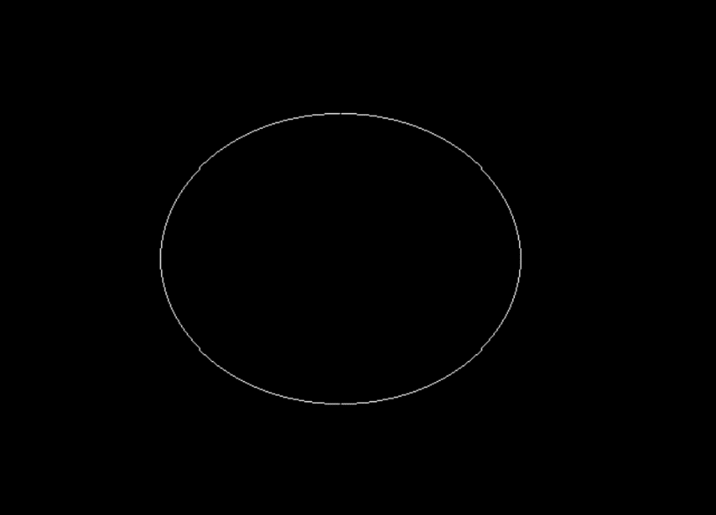

*Fig. 6.1: Output of Midpoint Ellipse Algorithm*